Team Details

1)Inspiron

Institute Name : G H raisoni college of engineering nagpur

Project Name : Energy Tracking System

Team Name : Inspiron

Team Size : 2

Email : gaureshp2@gmail.com

Team members :

1) Name : Gauresh Patil

Department : CSE

Mobile No. : 8857847166

Email ID. : gaureshp2@gmail.com

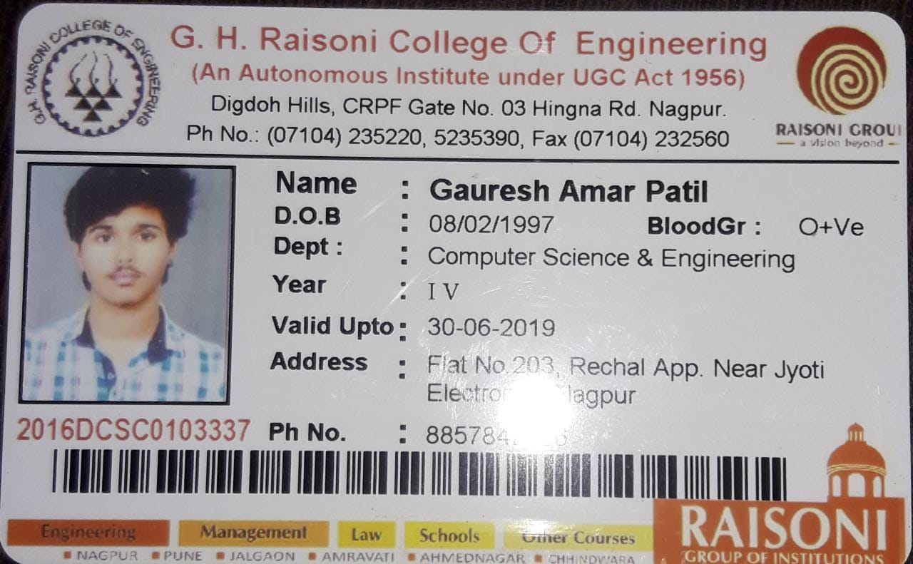

2) Name : Himanshi Yadav

Department : CSE

Mobile No. : 7276487746

Email ID. : himanshiyadav89@gmail.com

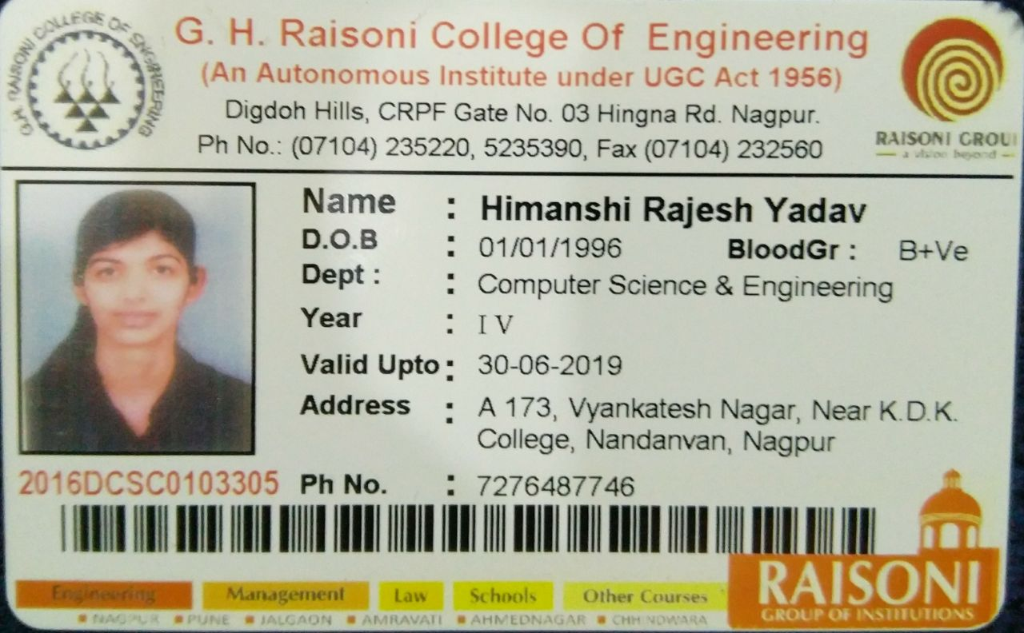

2)Raisoni1

Institute Name : G H RAISONI COLLEGE OF ENGINEERING NAGPUR

Project Name : Remote monitoring of sensor data from machine

Team Name : Raisoni1

Team Size : 5

Email : spnagrani@gmail.com

Team members :

1)Name : Ritik Nagpure

Department : EE

Mobile No. : 9511663971

Email ID. : nagpure_ritik.ghrceee@raisoni.net

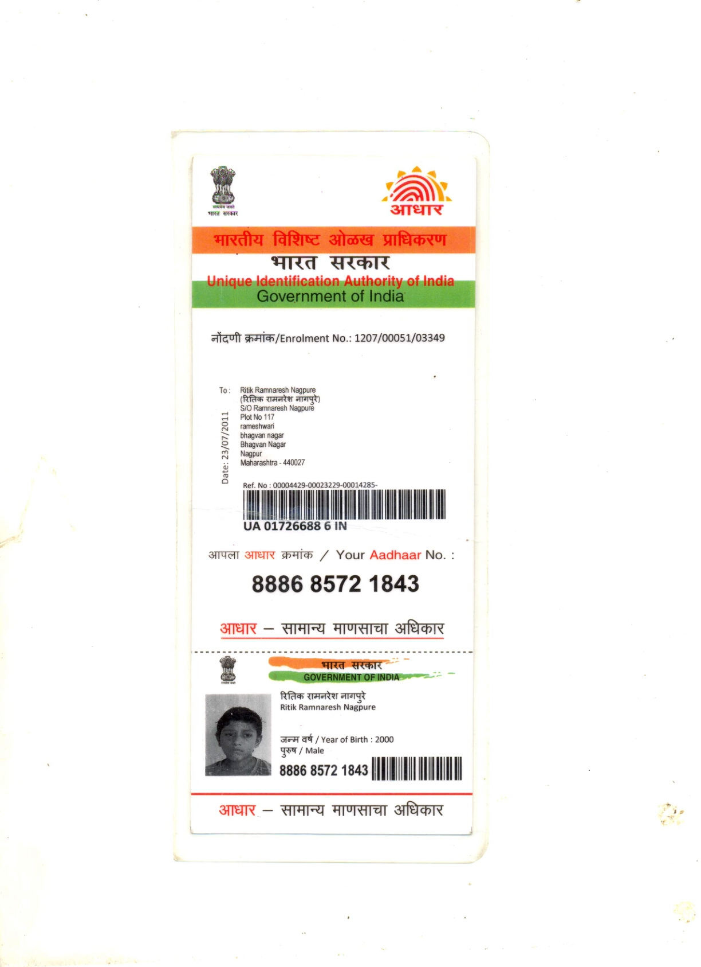

2)Name : Akshay Bhange

Department : EE

Mobile No. : 9595117348

Email ID. : bhange_akshay.ghrceee@raisoni.net

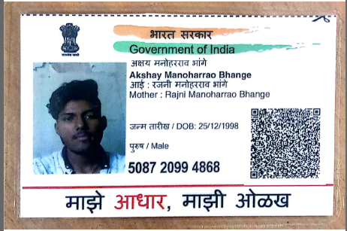

3)Name : Priya ranjan kumar

Department : IT

Mobile No. : 7721843497

Email ID. : kumar_priya.ghrceit@raisoni.net

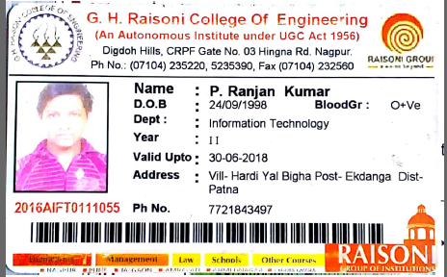

4)Name : Ashish Dhanraj Chokhandre

Department : EE

Mobile No. : 9561169015

Email ID. : chokhandre_ashish.ghrceee@raisoni.net

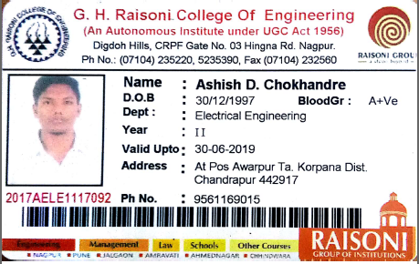

5)Name : Subrat Sapan Biswas

Department : IT

Mobile No. : 8888987538

Email ID. : biswas_subrat.ghrceit@raisoni.net

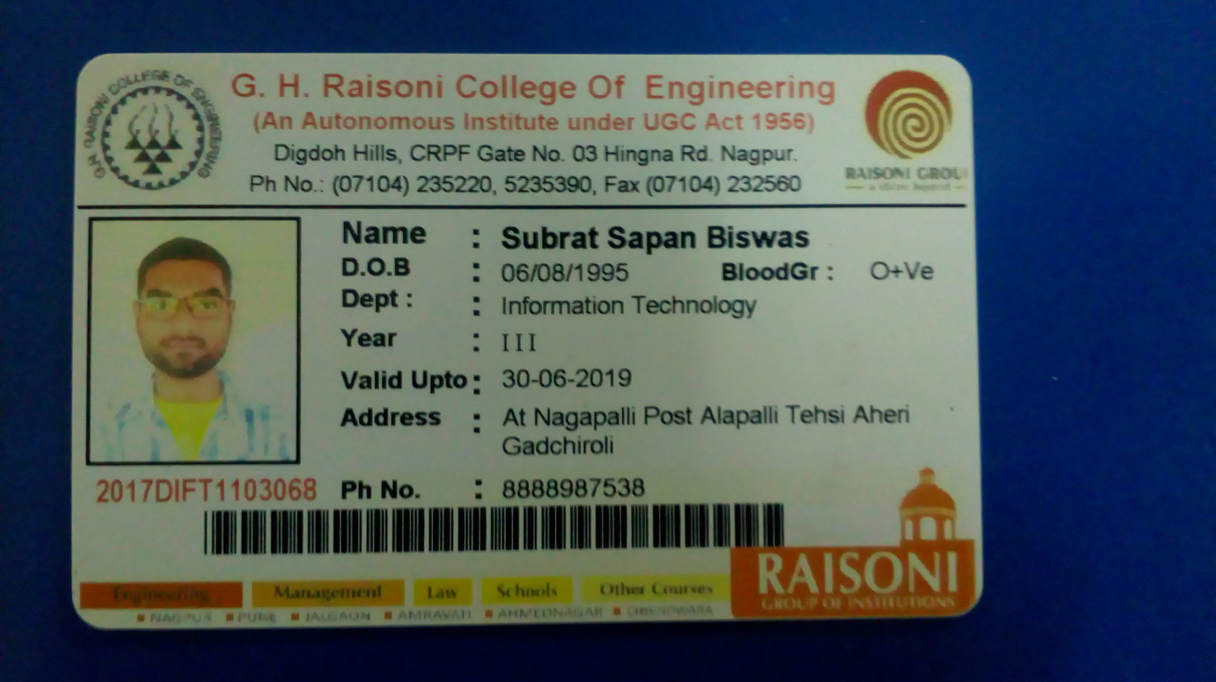

3)ANAL SALSHINGIKAR

Institute Name : GH RAISONI INSTITUTE OF ENGINEERING AND TECHNOLOGY NAGPUR

Project Name : Emergency Contact Service

Team Name : ANAL SALSHINGIKAR

Team Size : 5

Email : analswarn@gmail.com

Team members :

1)Name : ANAL SALSHINGIKAR

Department : CSE

Mobile No. : 8989028109

Email ID. : analswarn@gmail.com

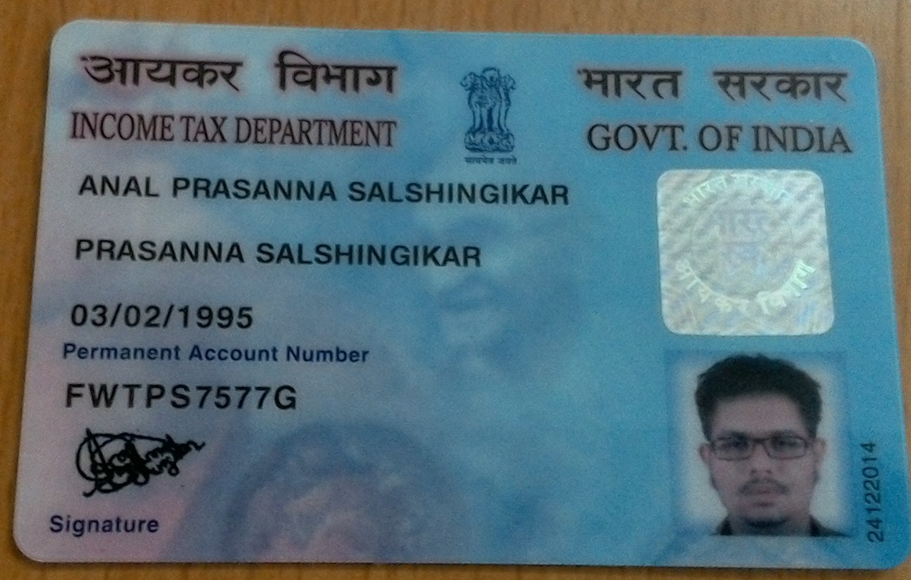

2)Name : BHARTI DHAKATE

Department : CSE

Mobile No. : 9049508473

Email ID. : bhartidhakate11.bd@gmail.com

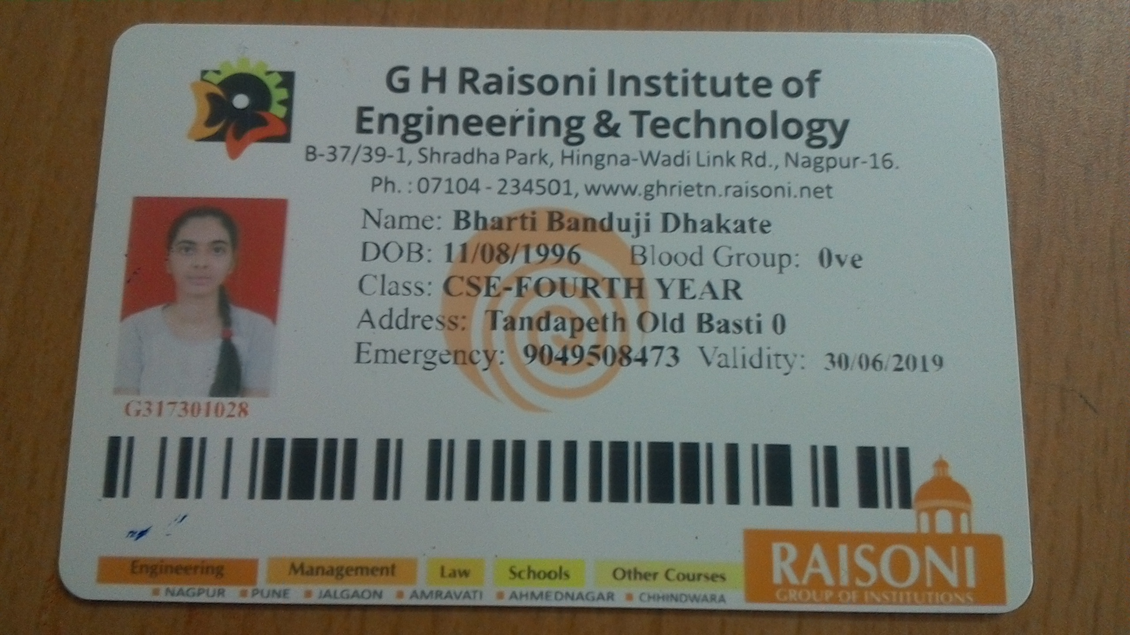

3)Name : Dhanshree Balpande

Department : CSE

Mobile No. : 7057369448

Email ID. : dhanshreebalpande@gmail.com

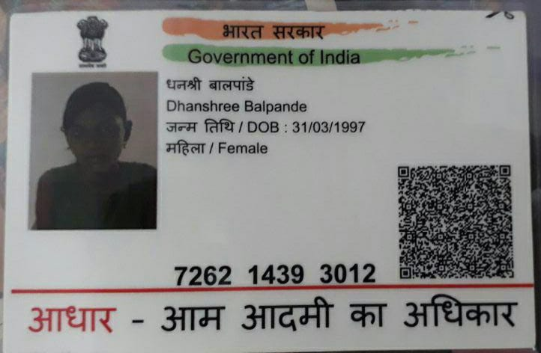

4)Name : MINAL ZILPELWAR

Department : CSE

Mobile No. : 8888382038

Email ID. : zilpelwarminal@gmail.com

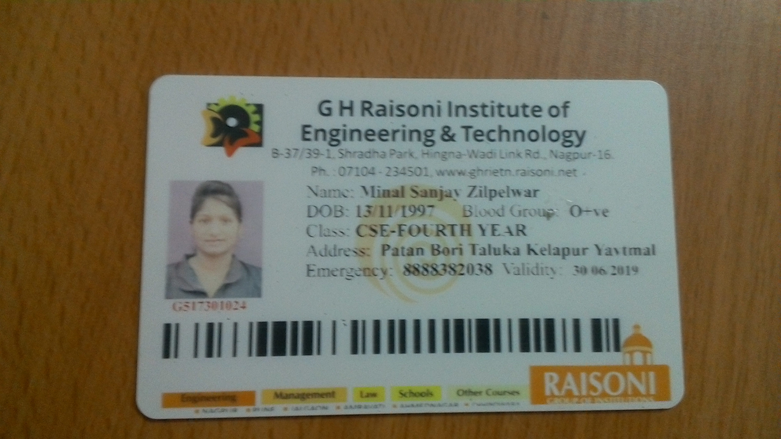

5)Name : SAKSHI MALI

Department : CSE

Mobile No. : 7869016718

Email ID. : sakshimali.97@gmail.com

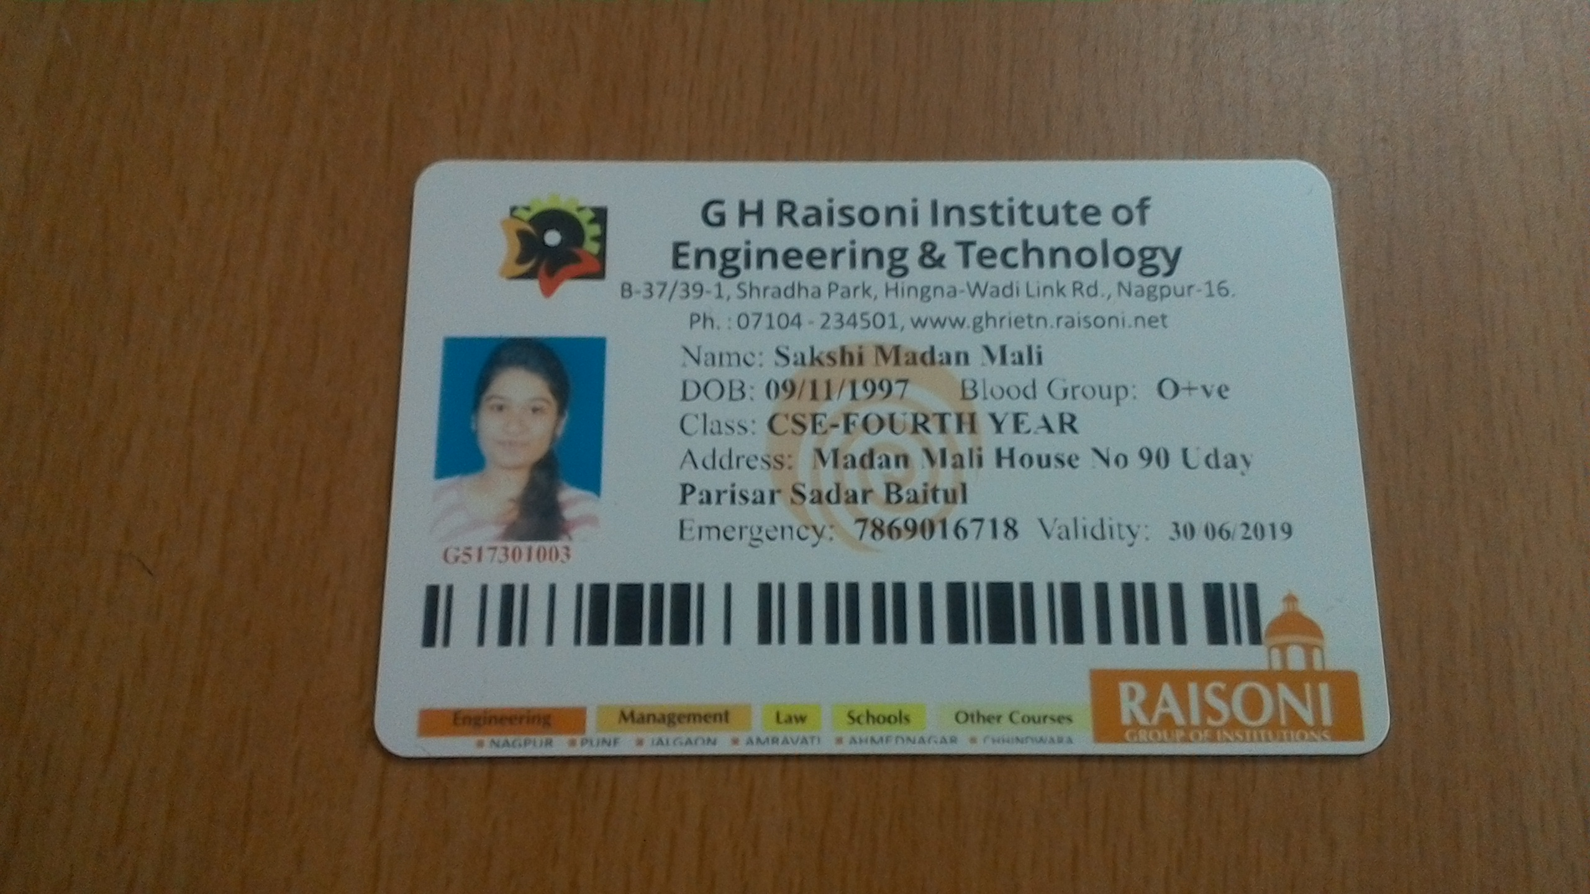

4)Neha shahu

Institute Name : Priyadarshini college of engineering

Project Name : Wastage Analysis

Team Name : Neha shahu

Team Size : 5

Email : gautamleena1@gmail.com

Team members :

1)Name : Neha shahu

Department : Computer technology

Mobile No. : 9763092830

Email ID. : nehashahu111@gmail.com

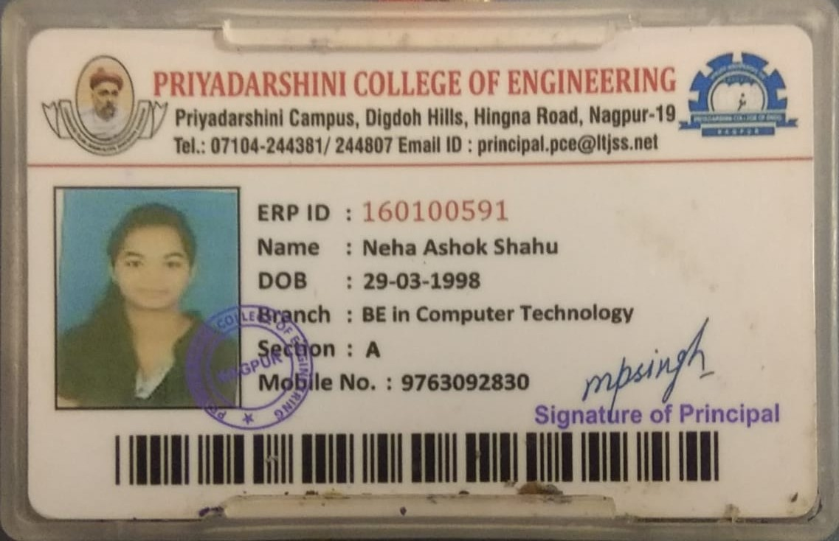

2)Name : Shweta jagtap

Department : Computer technology

Mobile No. : 9552067425

Email ID. : shwetajagtap500@gmail.com

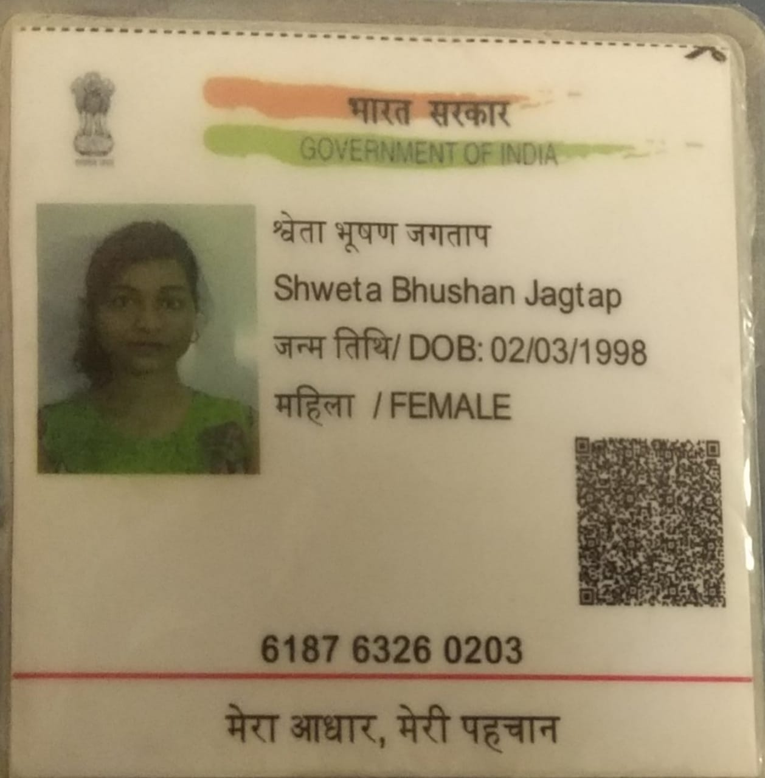

3)Name : Anushree Gupta

Department : Computer technology

Mobile No. : 9503588370

Email ID. : anushreegupta2301@gmail.com

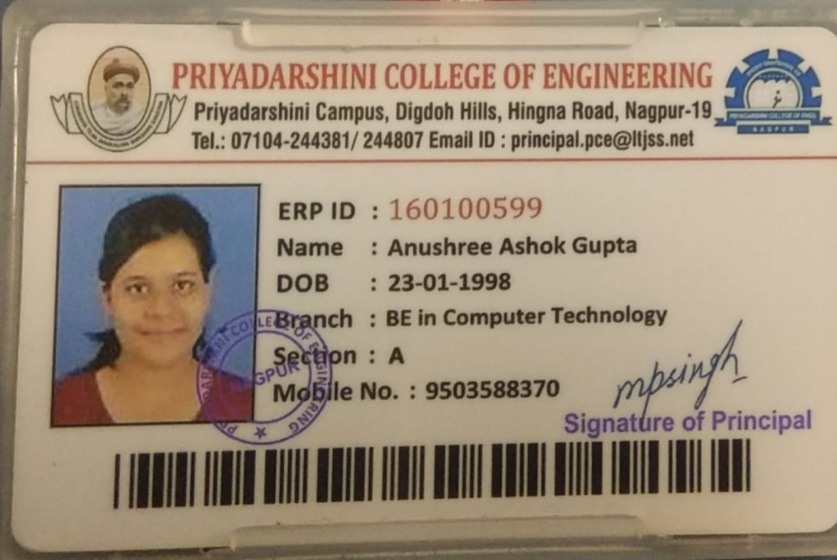

4)Name : Chetna Ambhorkar

Department : Computer technology

Mobile No. : 8446552895

Email ID. : chetnaambhorkar@gmail.com

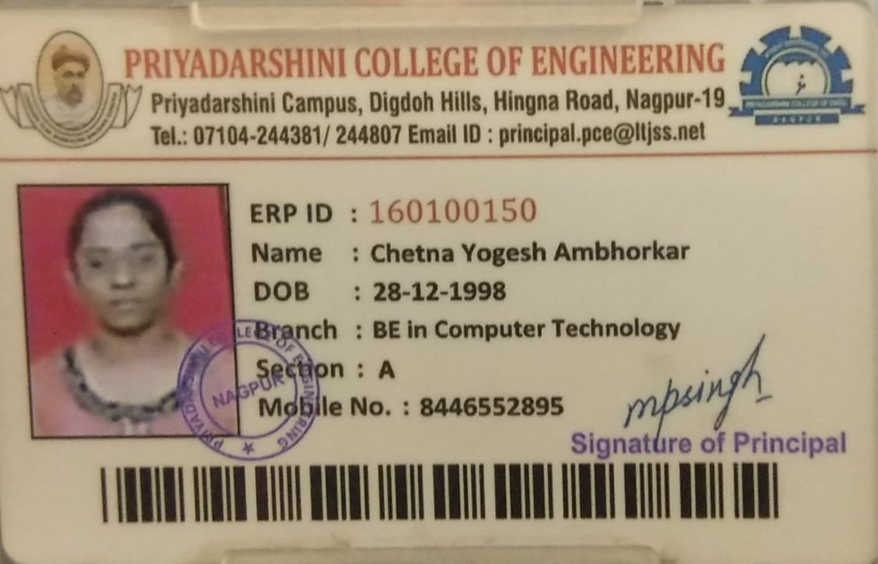

5)Name : Leena gautam

Department : Computer technology

Mobile No. : 7304188224

Email ID. : gautamleena1@gmail.com

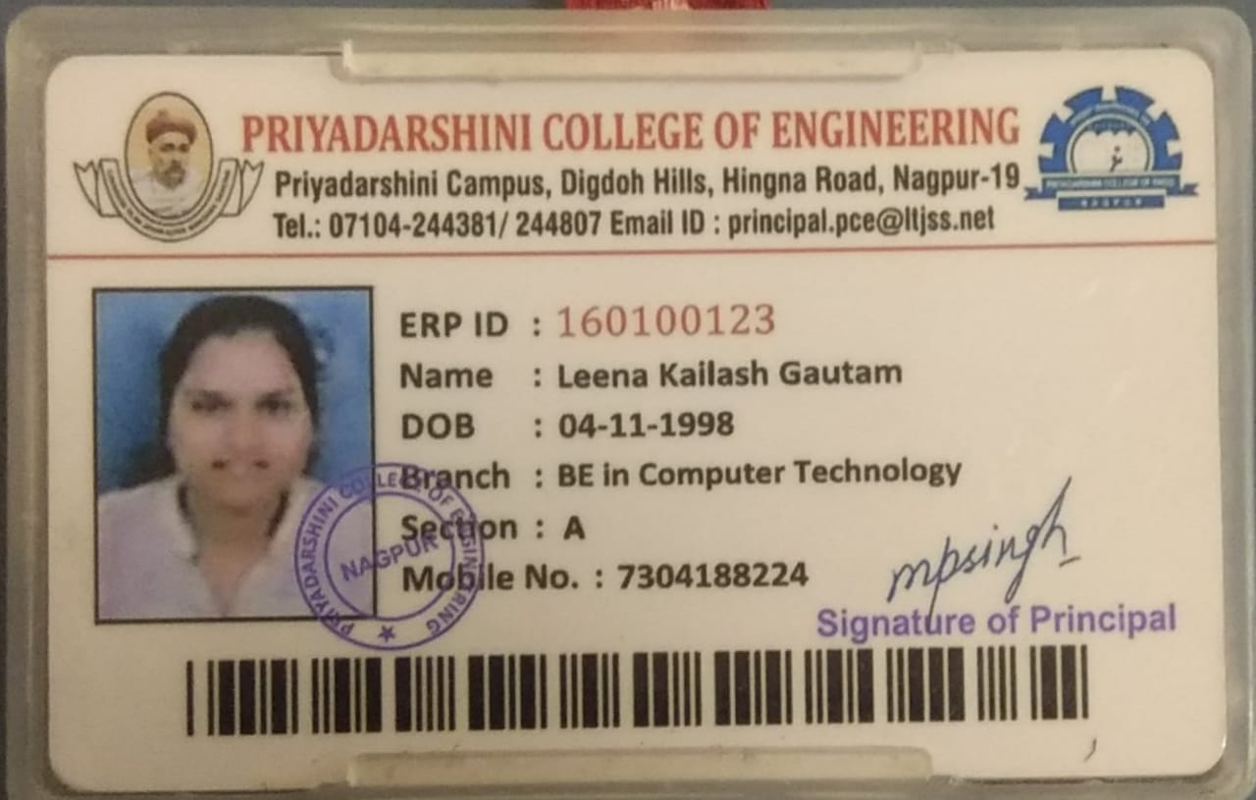

5)ELECTRIFIERS

Institute Name : DR. BABASAHEB AMBEDKAR COLLEGE OF ENGINEERING & RESERCH, NAGPUR

Project Name : Wastage Analysis

Team Name : ELECTRIFIERS

Team Size : 5

Email : shrusti96bhutange@gmail.com

Team members :

1)Name : SHRUSTI RAJAHANSH BHUTANGE

Department : ELECTRICAL

Mobile No. : 8446521789

Email ID. : shrusti96bhutange@gmail.com

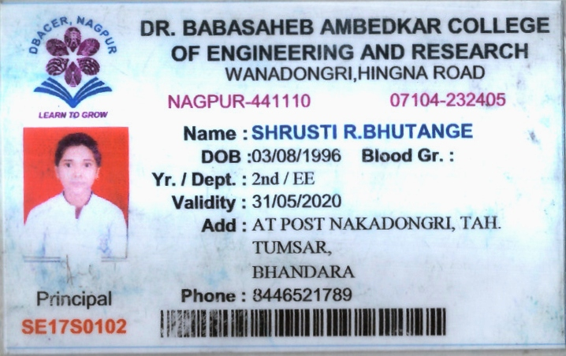

2)Name : PURVA VIKRAM JOSHI

Department : ELECTRICAL

Mobile No. : 8830910831

Email ID. : purvajoshi258@gmail.com

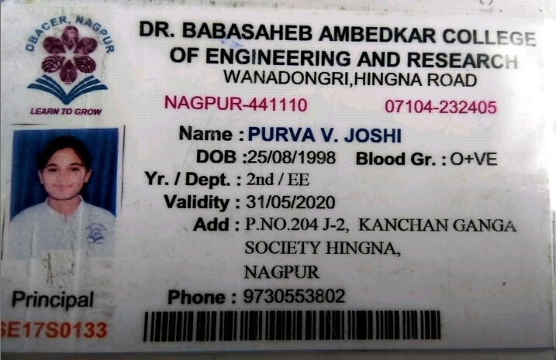

3)Name : KHUSHBOO SHOBHARAM LUTE

Department : ELECTRICAL

Mobile No. : 8928033575

Email ID. : lutekhushboo@gmail.com

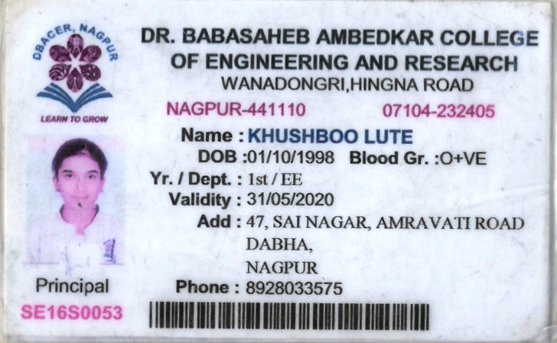

4)Name : KARUNA NAMDEORAO TAWADE

Department : ELECTRICAL

Mobile No. : 9145541082

Email ID. : karunatawade30@gmail.com

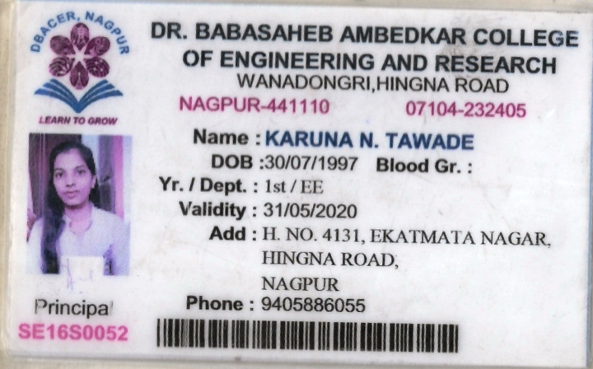

5)Name : DR. SHILPA KALAMBE

Department : ELECTRICAL

Mobile No. : 9975914446

Email ID. : shilpakalambe@gmail.com

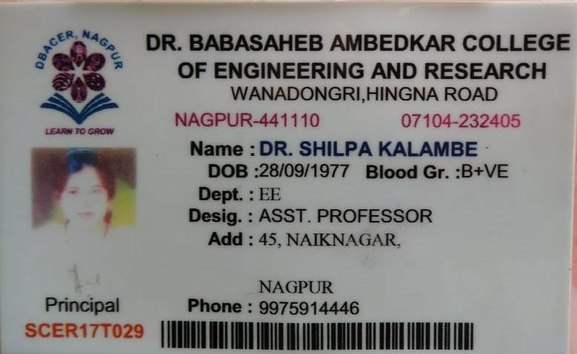

6)TECH-ARMY

Institute Name : G H Raisoni Institute of Engineering and Technology,Nagpur

Project Name : Air Quality Monitoring

Team Name : TECH-ARMY

Team Size : 5

Email : thakre.kartik.2910@gmail.com

Team members :

1)Name : Kartik Thakre

Department : Computer Sciecne and Engineering

Mobile No. : 7020770319

Email ID. : thakre.kartik.2910@gmail.com

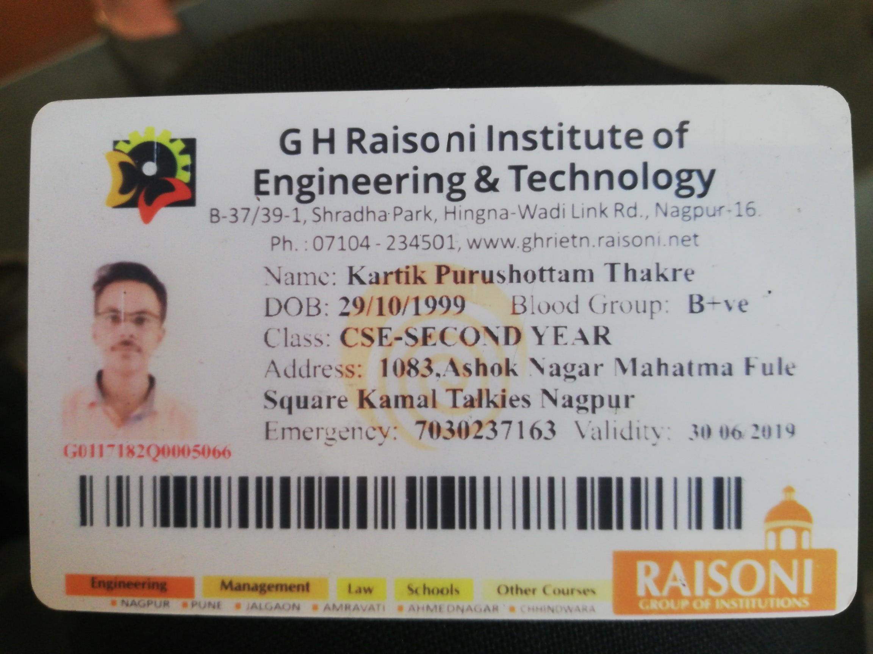

2)Name : Sonal Agrawal

Department : Computer Sciecne and Engineering

Mobile No. : 8657772348

Email ID. : sonalsinghal755@gmail.com

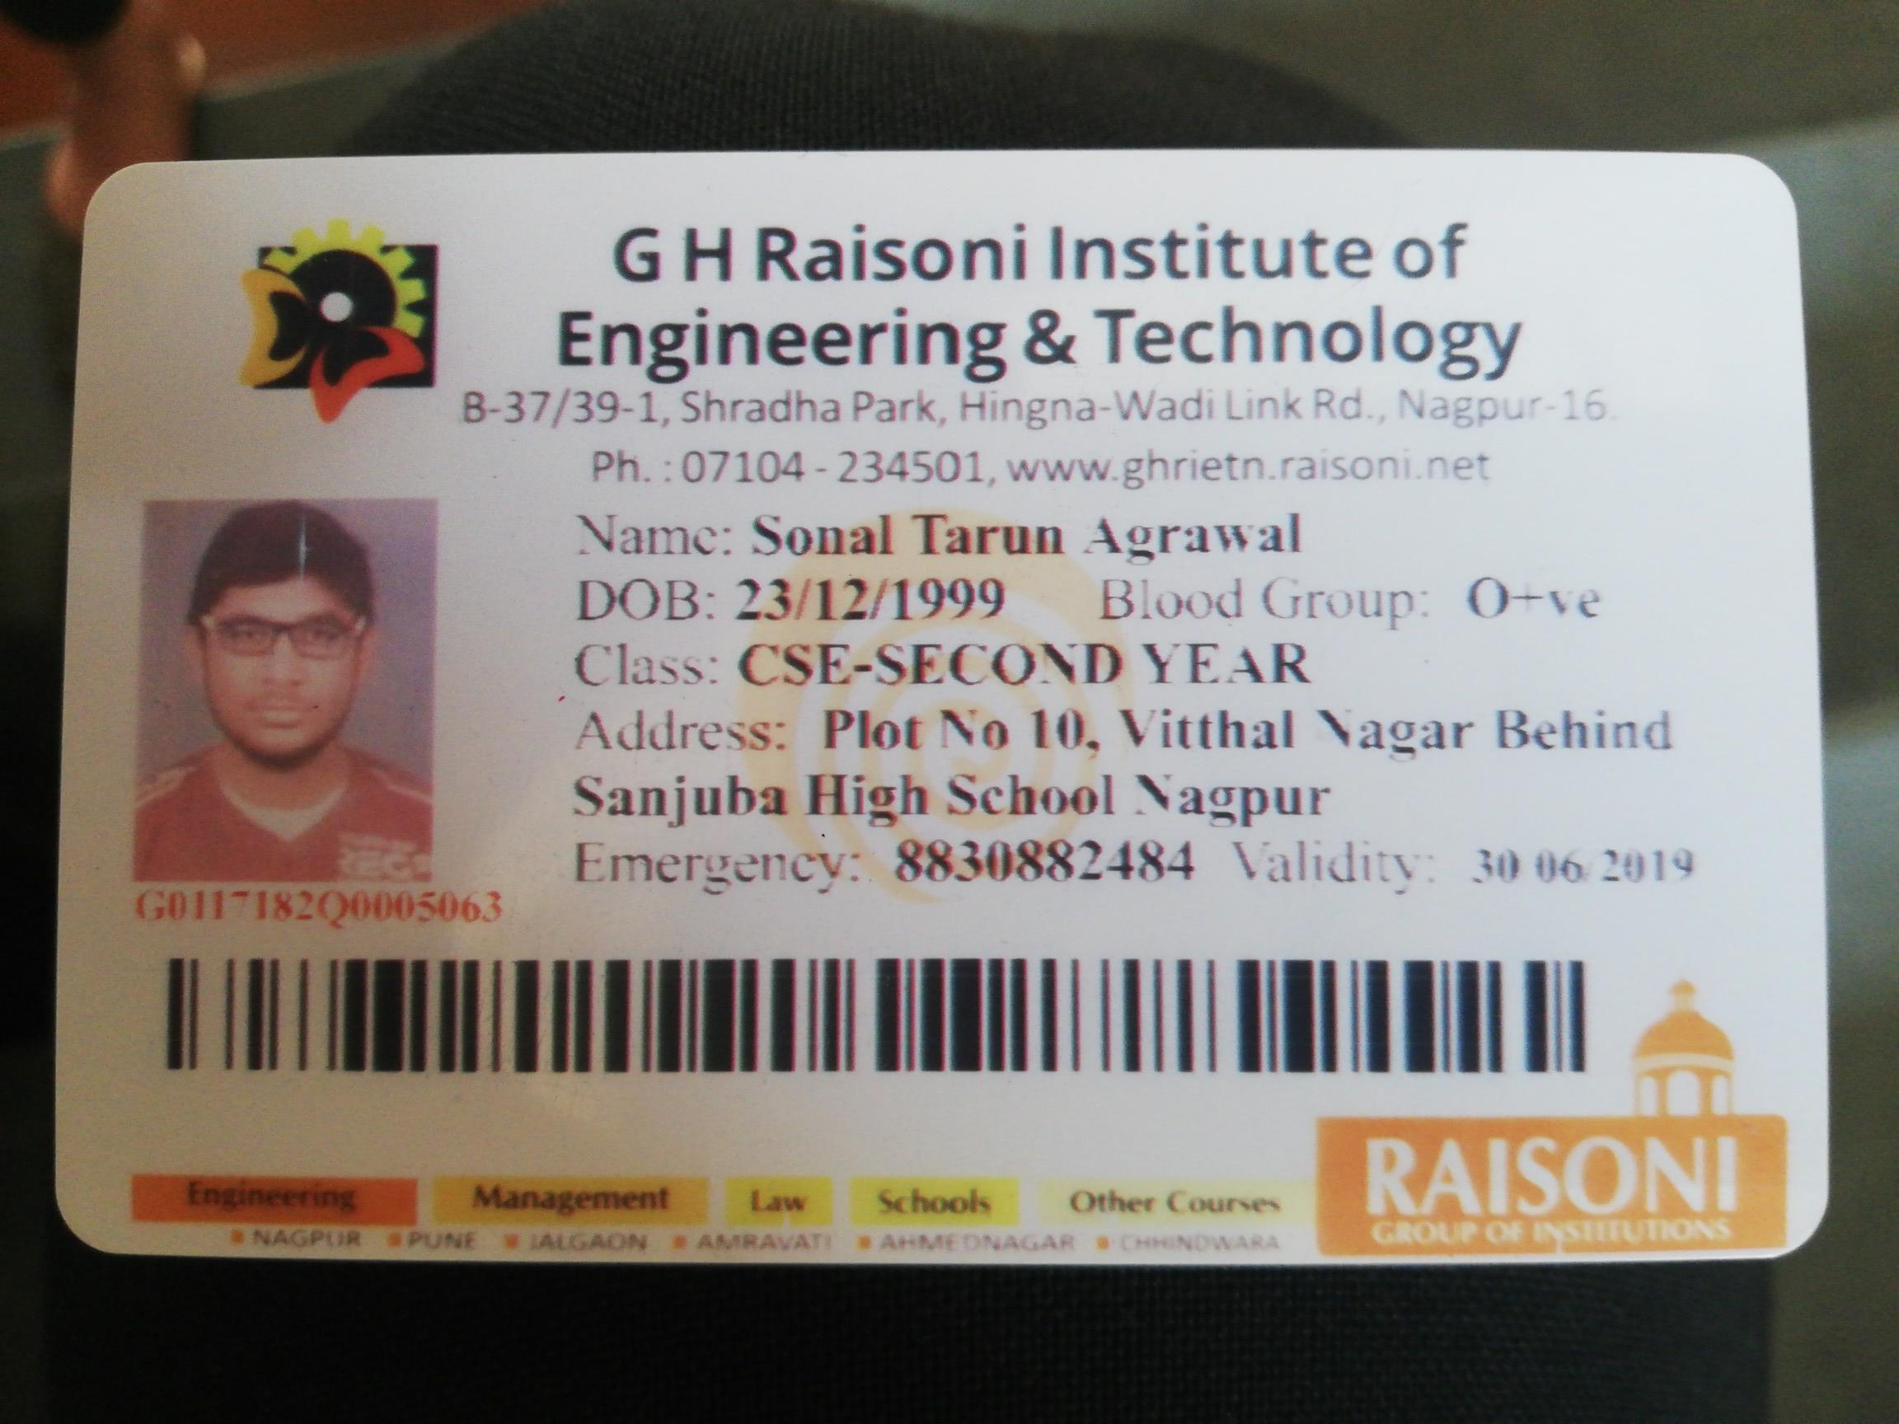

3)Name : Bhagyashree Avhadkar

Department : Computer Sciecne and Engineering

Mobile No. : 7796820933

Email ID. : avhadkarbhagyashree@gmail.com

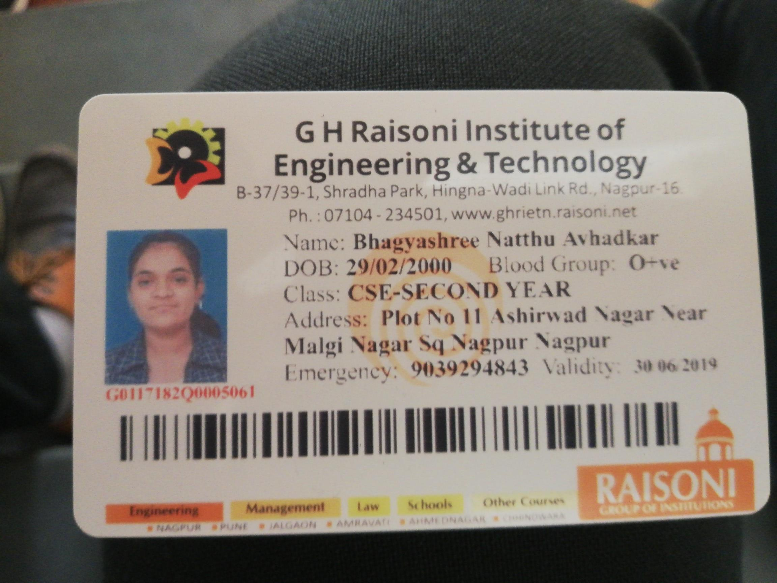

4)Name : Sanchayati Bajganiya

Department : Computer Sciecne and Engineering

Mobile No. : 9767994454

Email ID. : netrabajgania12@gmail.com



5)Name : Yogesh Golhar

Department : Computer Sciecne and Engineering

Mobile No. : 9833659475

Email ID. : yogesh.golhar28@gmail.com

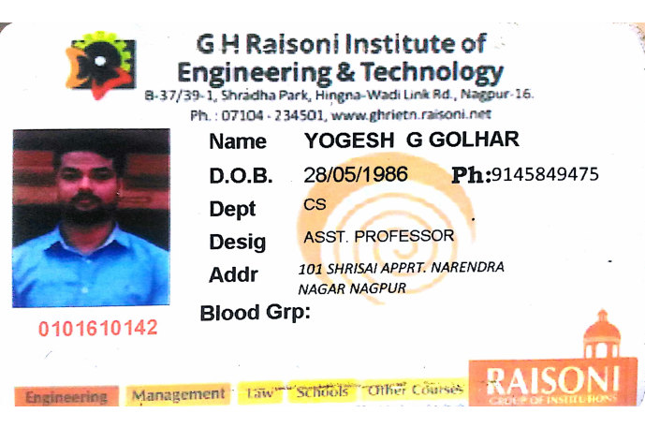

7)Pravesh Bawangade

Institute Name : St. Vincent Pallotti College of Engineering and Technology

Project Name : Air Quality Monitoring

Team Name : Pravesh Bawangade

Team Size : 4

Email : pptechno52@gmail.com

Team members :

1)Name : Pravesh Muneshwar Bawangade

Department : ENTC

Mobile No. : 7276212434

Email ID. : pptechno52@gmail.com

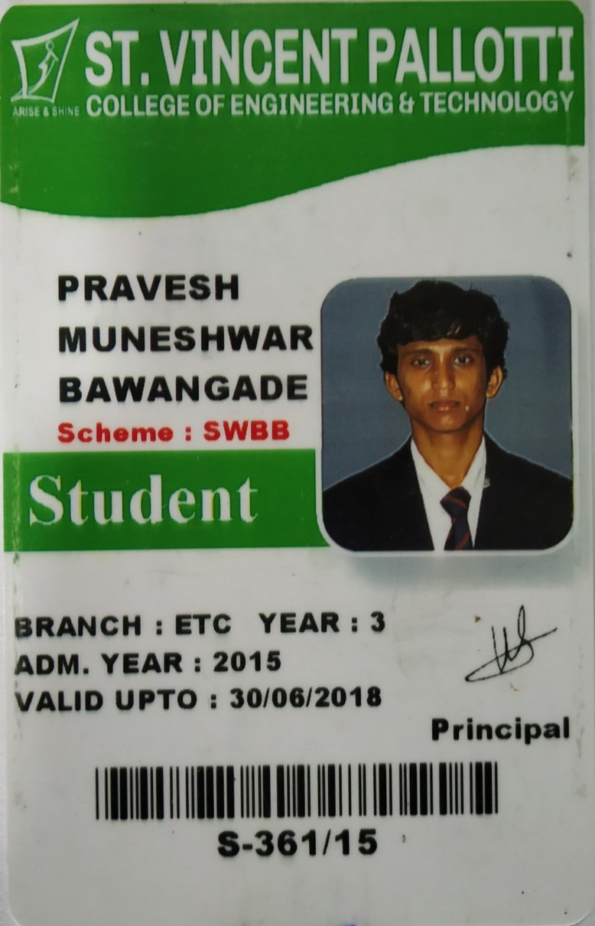

2)Name : Akshay Patil

Department : ENTC

Mobile No. : 9975735102

Email ID. : patila352@gmail.com

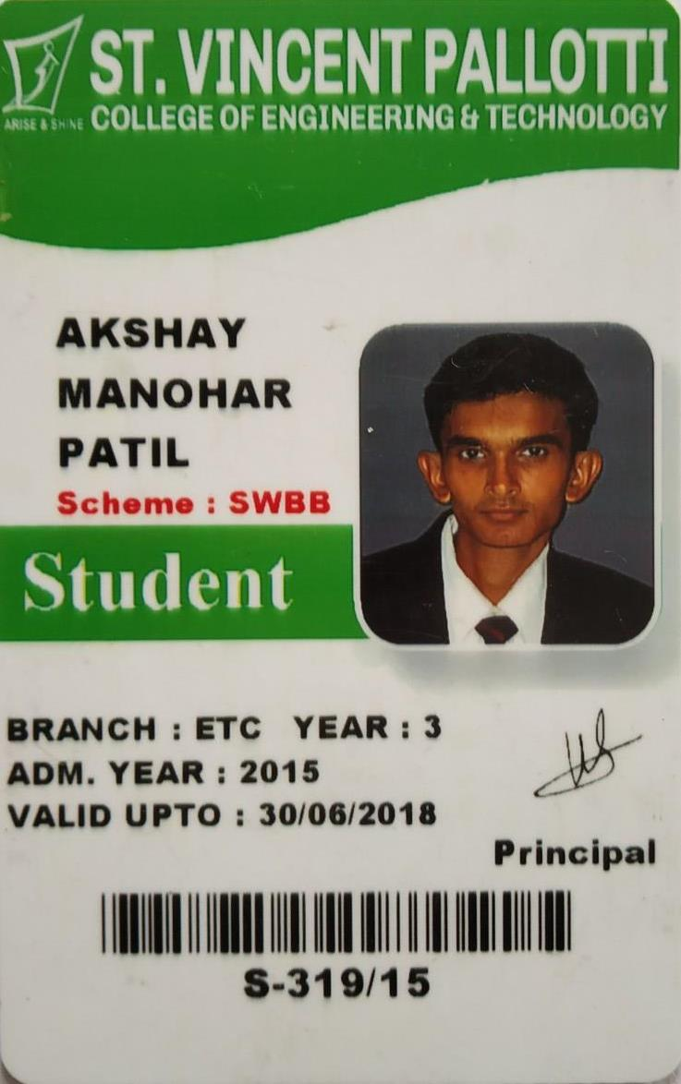

3)Name : Nupur Kohadkar

Department : ENTC

Mobile No. : 9960165434

Email ID. : nupurkohadkar1997@gmail.com

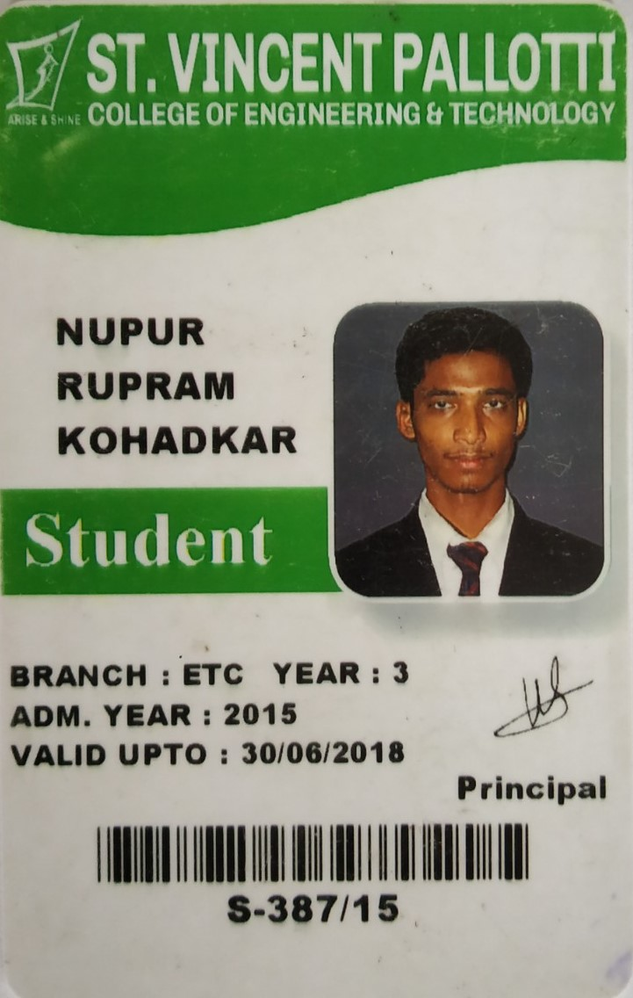

4)Name : Rohan Vaidya

Department : ENTC

Mobile No. : 9766590227

Email ID. : rnvaidya5@gmail.com

File:/app/public//uploads/2018/07/RS8shxE3OoG51532597637.jpg

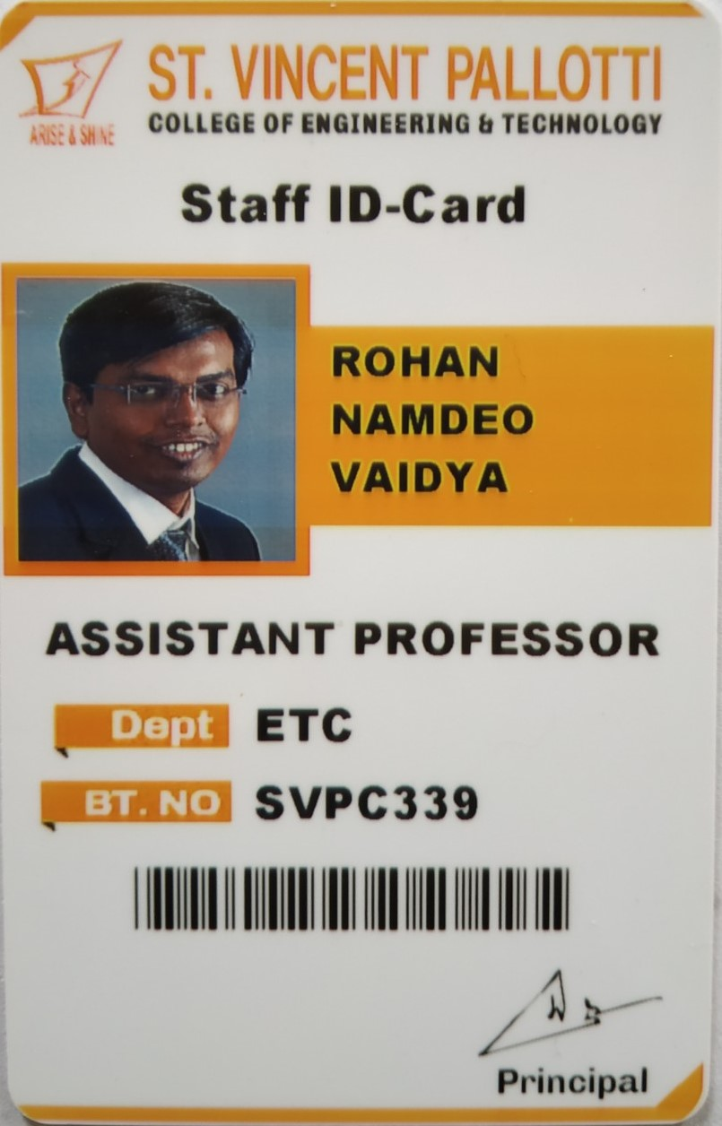

8)Tech Connect

Institute Name : Priyadarshini college of engineering

Project Name : Process-wise Order Tracking

Team Name : Tech Connect

Team Size : 5

Email : sngul8299@gmail.com

Team members :

1)Name : Srushti Gulhane

Department : Computer Technology

Mobile No. : 8177868216

Email ID. : sngul8299@gmail.com

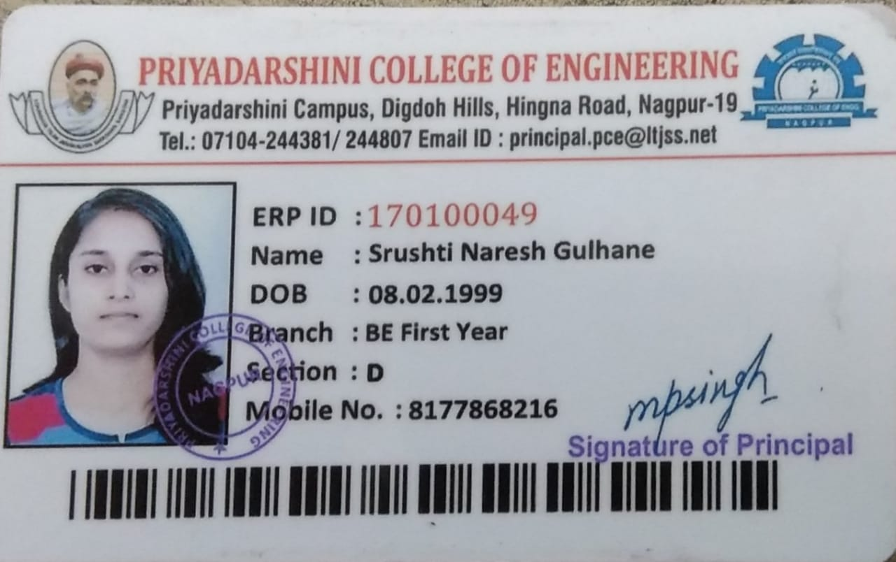

2)Name : Richa Sen

Department : Computer Technology

Mobile No. : 9158155553

Email ID. : richathrones@gmail.com

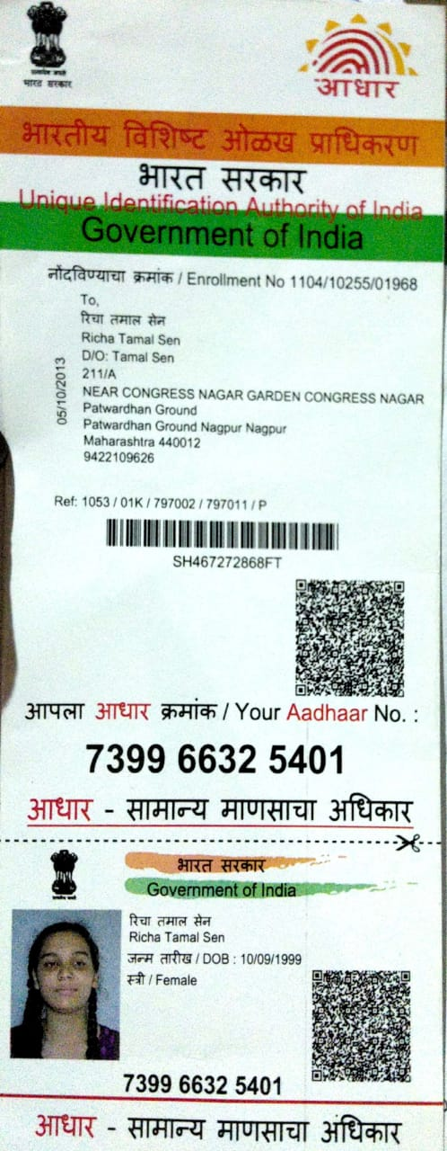

3)Name : Rubana Khan

Department : Computer

Mobile No. : 9923350611

Email ID. : rubi.tarannum@gmail.com

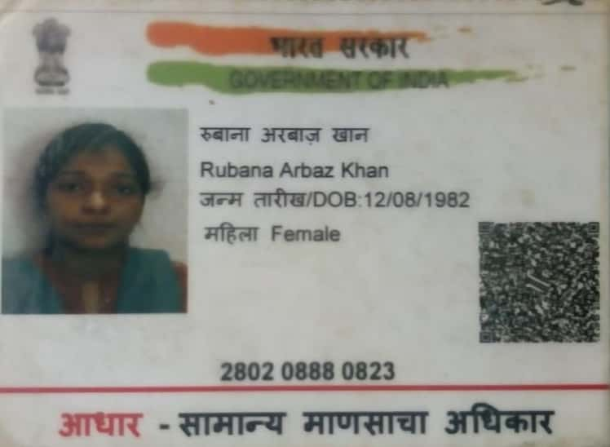

4)Name : Indranil Palit

Department : Electrical & Power

Mobile No. : 9503583601

Email ID. : indronilpalit2013@gmail.com

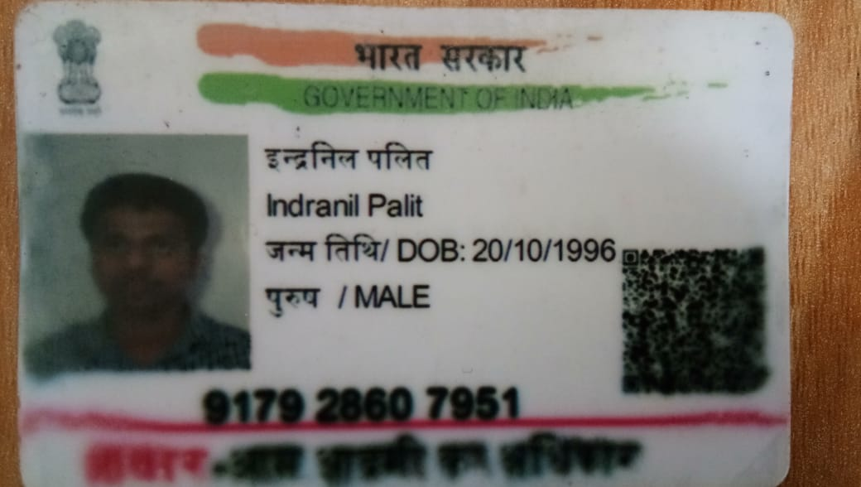

5)Name : Apurv Humne

Department : Electrical and Power

Mobile No. : 8999048525

Email ID. : apurvhumne3@gmail.com

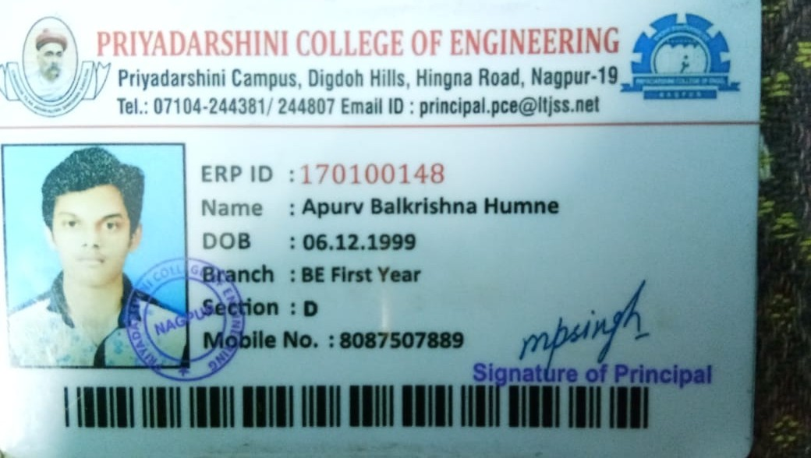

9)Atharva Punde

Institute Name : Priyadarshini College Of Engineering

Project Name : Emergency Contact Service

Team Name : Atharva Punde

Team Size : 5

Email : atharvammm15@gmail.com

Team members :

1)Name : Atharva Punde

Department : Computer technology

Mobile No. : 9146326794

Email ID. : atharvammm15@gmail.com

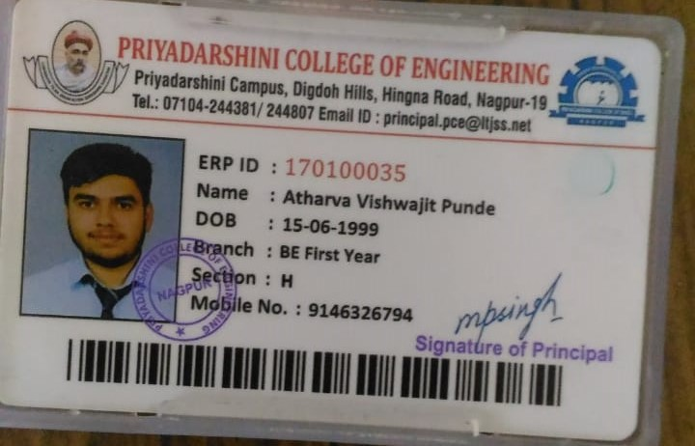

2)Name : Hardik Kajne

Department : Computer Technology

Mobile No. : 9172738228

Email ID. : hardikkajne@gmail.com

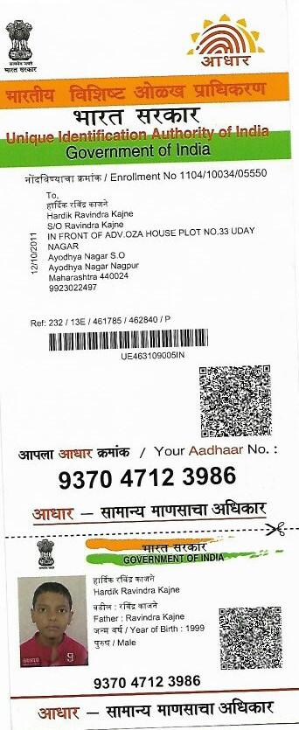

3)Name : Harshada Khadse

Department : Computer Technology

Mobile No. : 8378951744

Email ID. : khadseharshu123@gmail.com

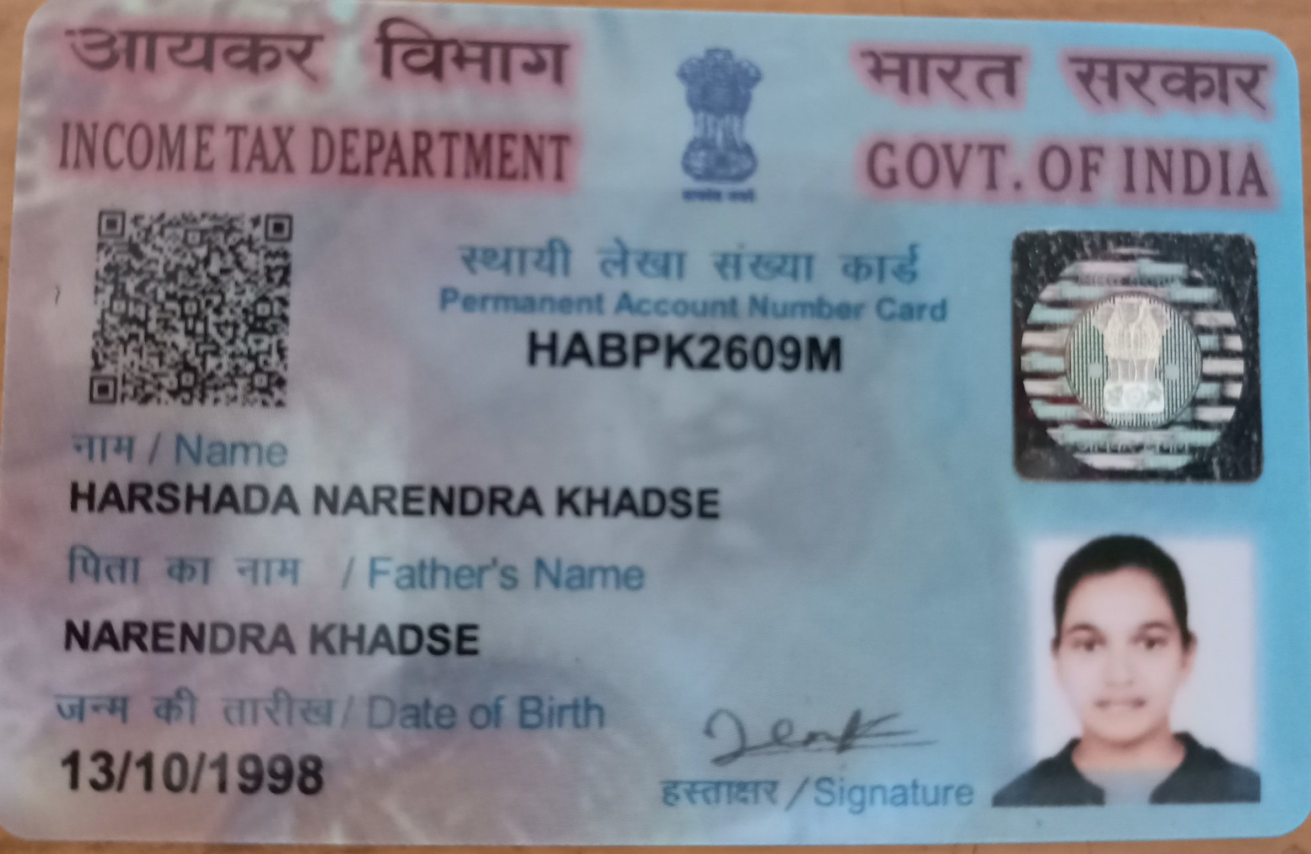

4)Name : Krutakshi Gokhale

Department : Computer Technology

Mobile No. : 7745822660

Email ID. : krutakshi1234@gmail.com

File:/app/public//uploads/2018/07/EqcCMonCaOOF1532599953.partial

5)Name : Ms. Nita Thakre

Department : Computer Technology

Mobile No. : 9970575309

Email ID. : nitathakre14@gmail.com

File:/app/public//uploads/2018/07/gOWk5QbCsywg1532600248.jpg

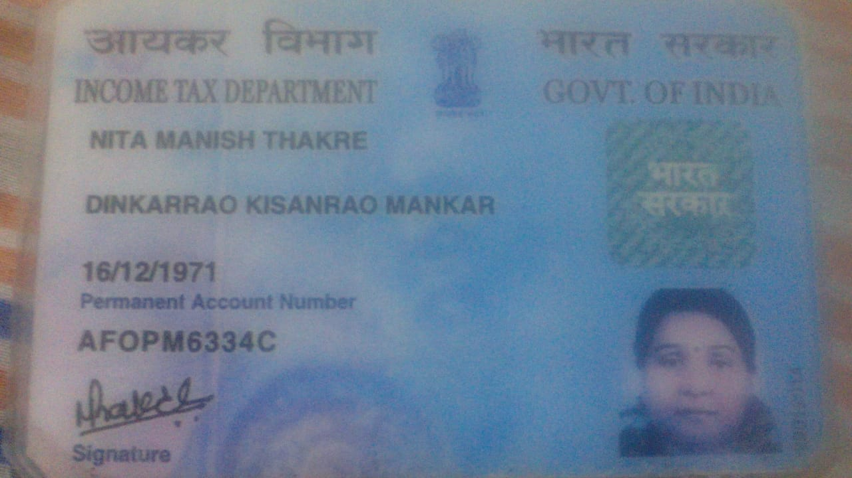

10)Code Slayers

Institute Name : St. Vincent Pallotti College Of Engineering &Technology,Nagpur

Project Name : Wastage Analysis

Team Name : Code Slayers

Team Size : 5

Email : manalithakre125@gmail.com

Team members :

1)Name : Manali A Thakre

Department : Information Technology

Mobile No. : 9766261305

Email ID. : manalithakre125@gmail.com

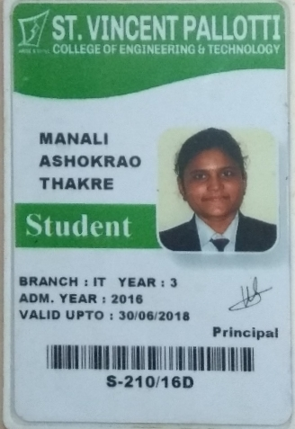

2)Name : Himani R Kumbhare

Department : Information Technology

Mobile No. : 7875725129

Email ID. : himanichoco02@gmail.com

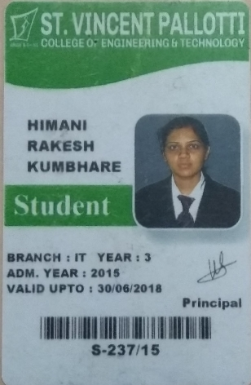

3)Name : Rashmi N Bhilkar

Department : Information Technology

Mobile No. : 7741041050

Email ID. : rashmibhilkar07@gmail.com

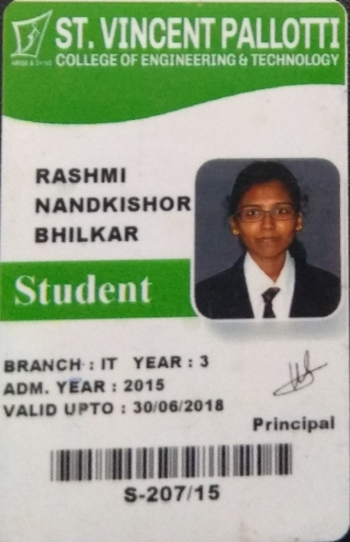

4)Name : Prerana S Modala

Department : Information Technology

Mobile No. : 8329452741

Email ID. : preranasagar22@gmail.com

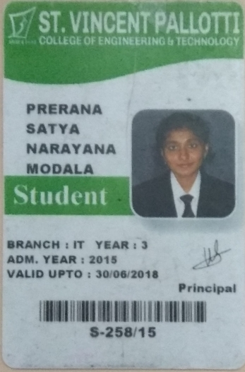

5)Name : Shabana Pathan

Department : Information Technology

Mobile No. : 8605008799

Email ID. : sbn.pathan@gmail.com

